**NATIONAL INSTITUTE OF TECHNOLOGY SILCHAR**

**Cachar, Assam**

**B.Tech. IVth Sem**

**Subject Code:** CS216

**Subject Name:** Applied Probability

**Submitted By:**

Name : Subhojit Ghimire

Sch. Id. : 1912160

Branch : CSE – B

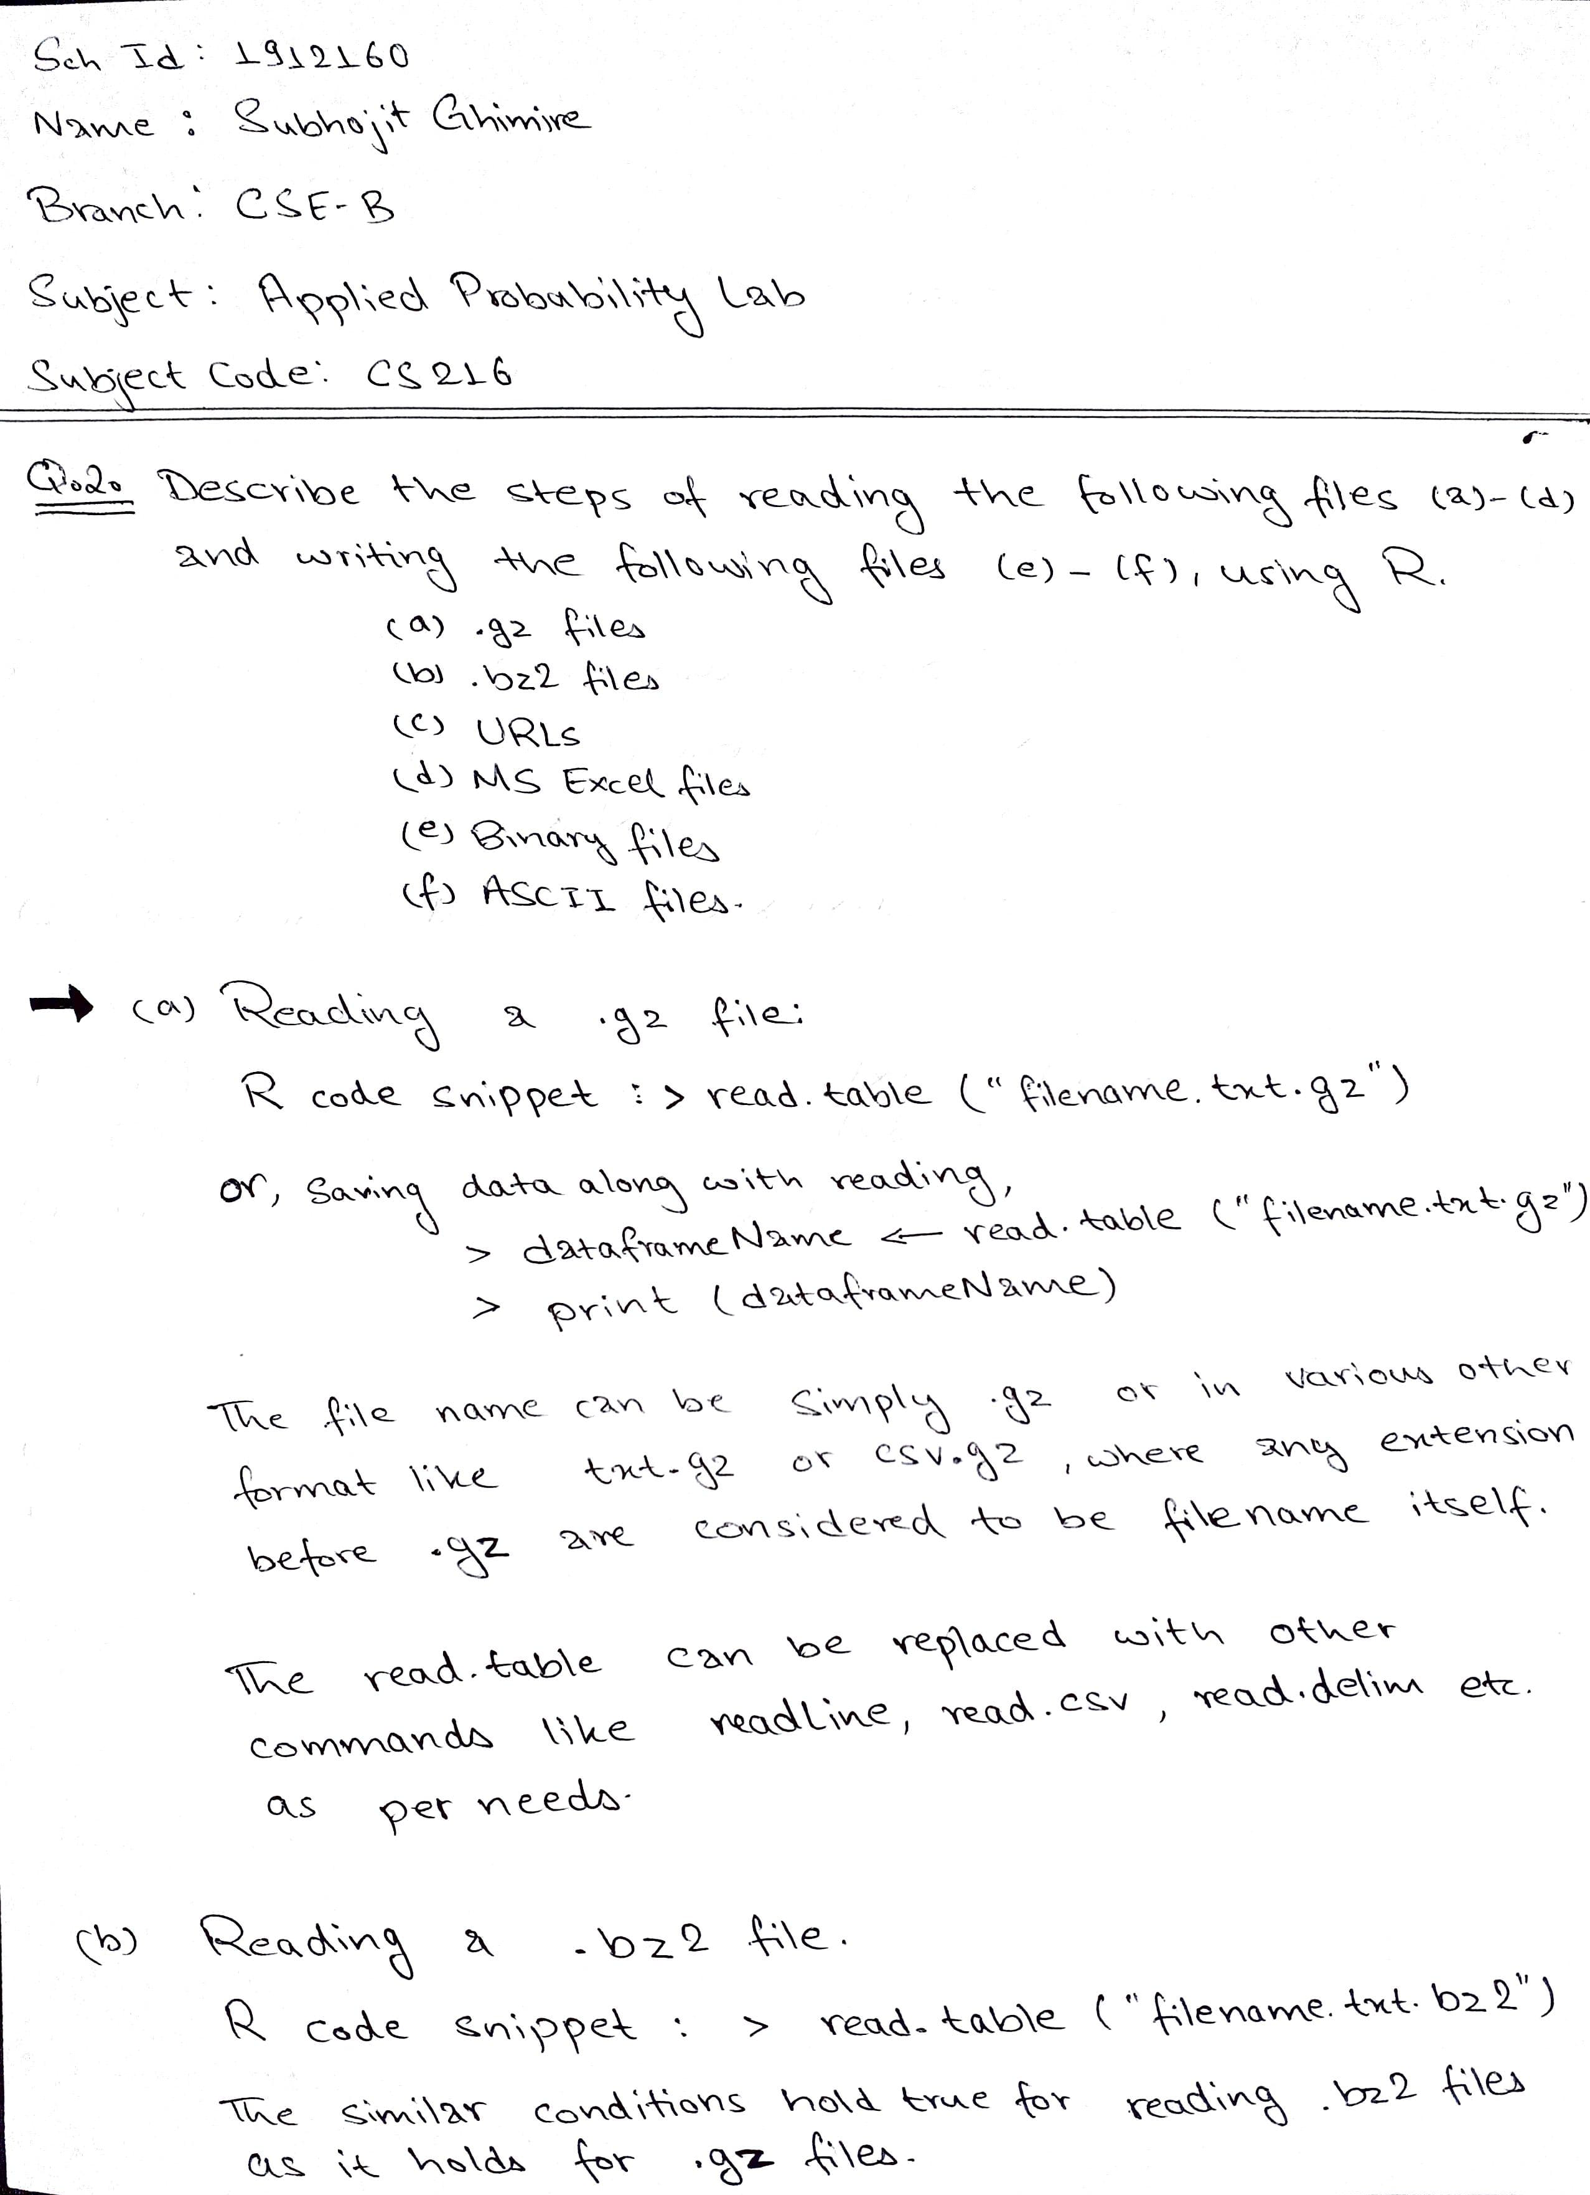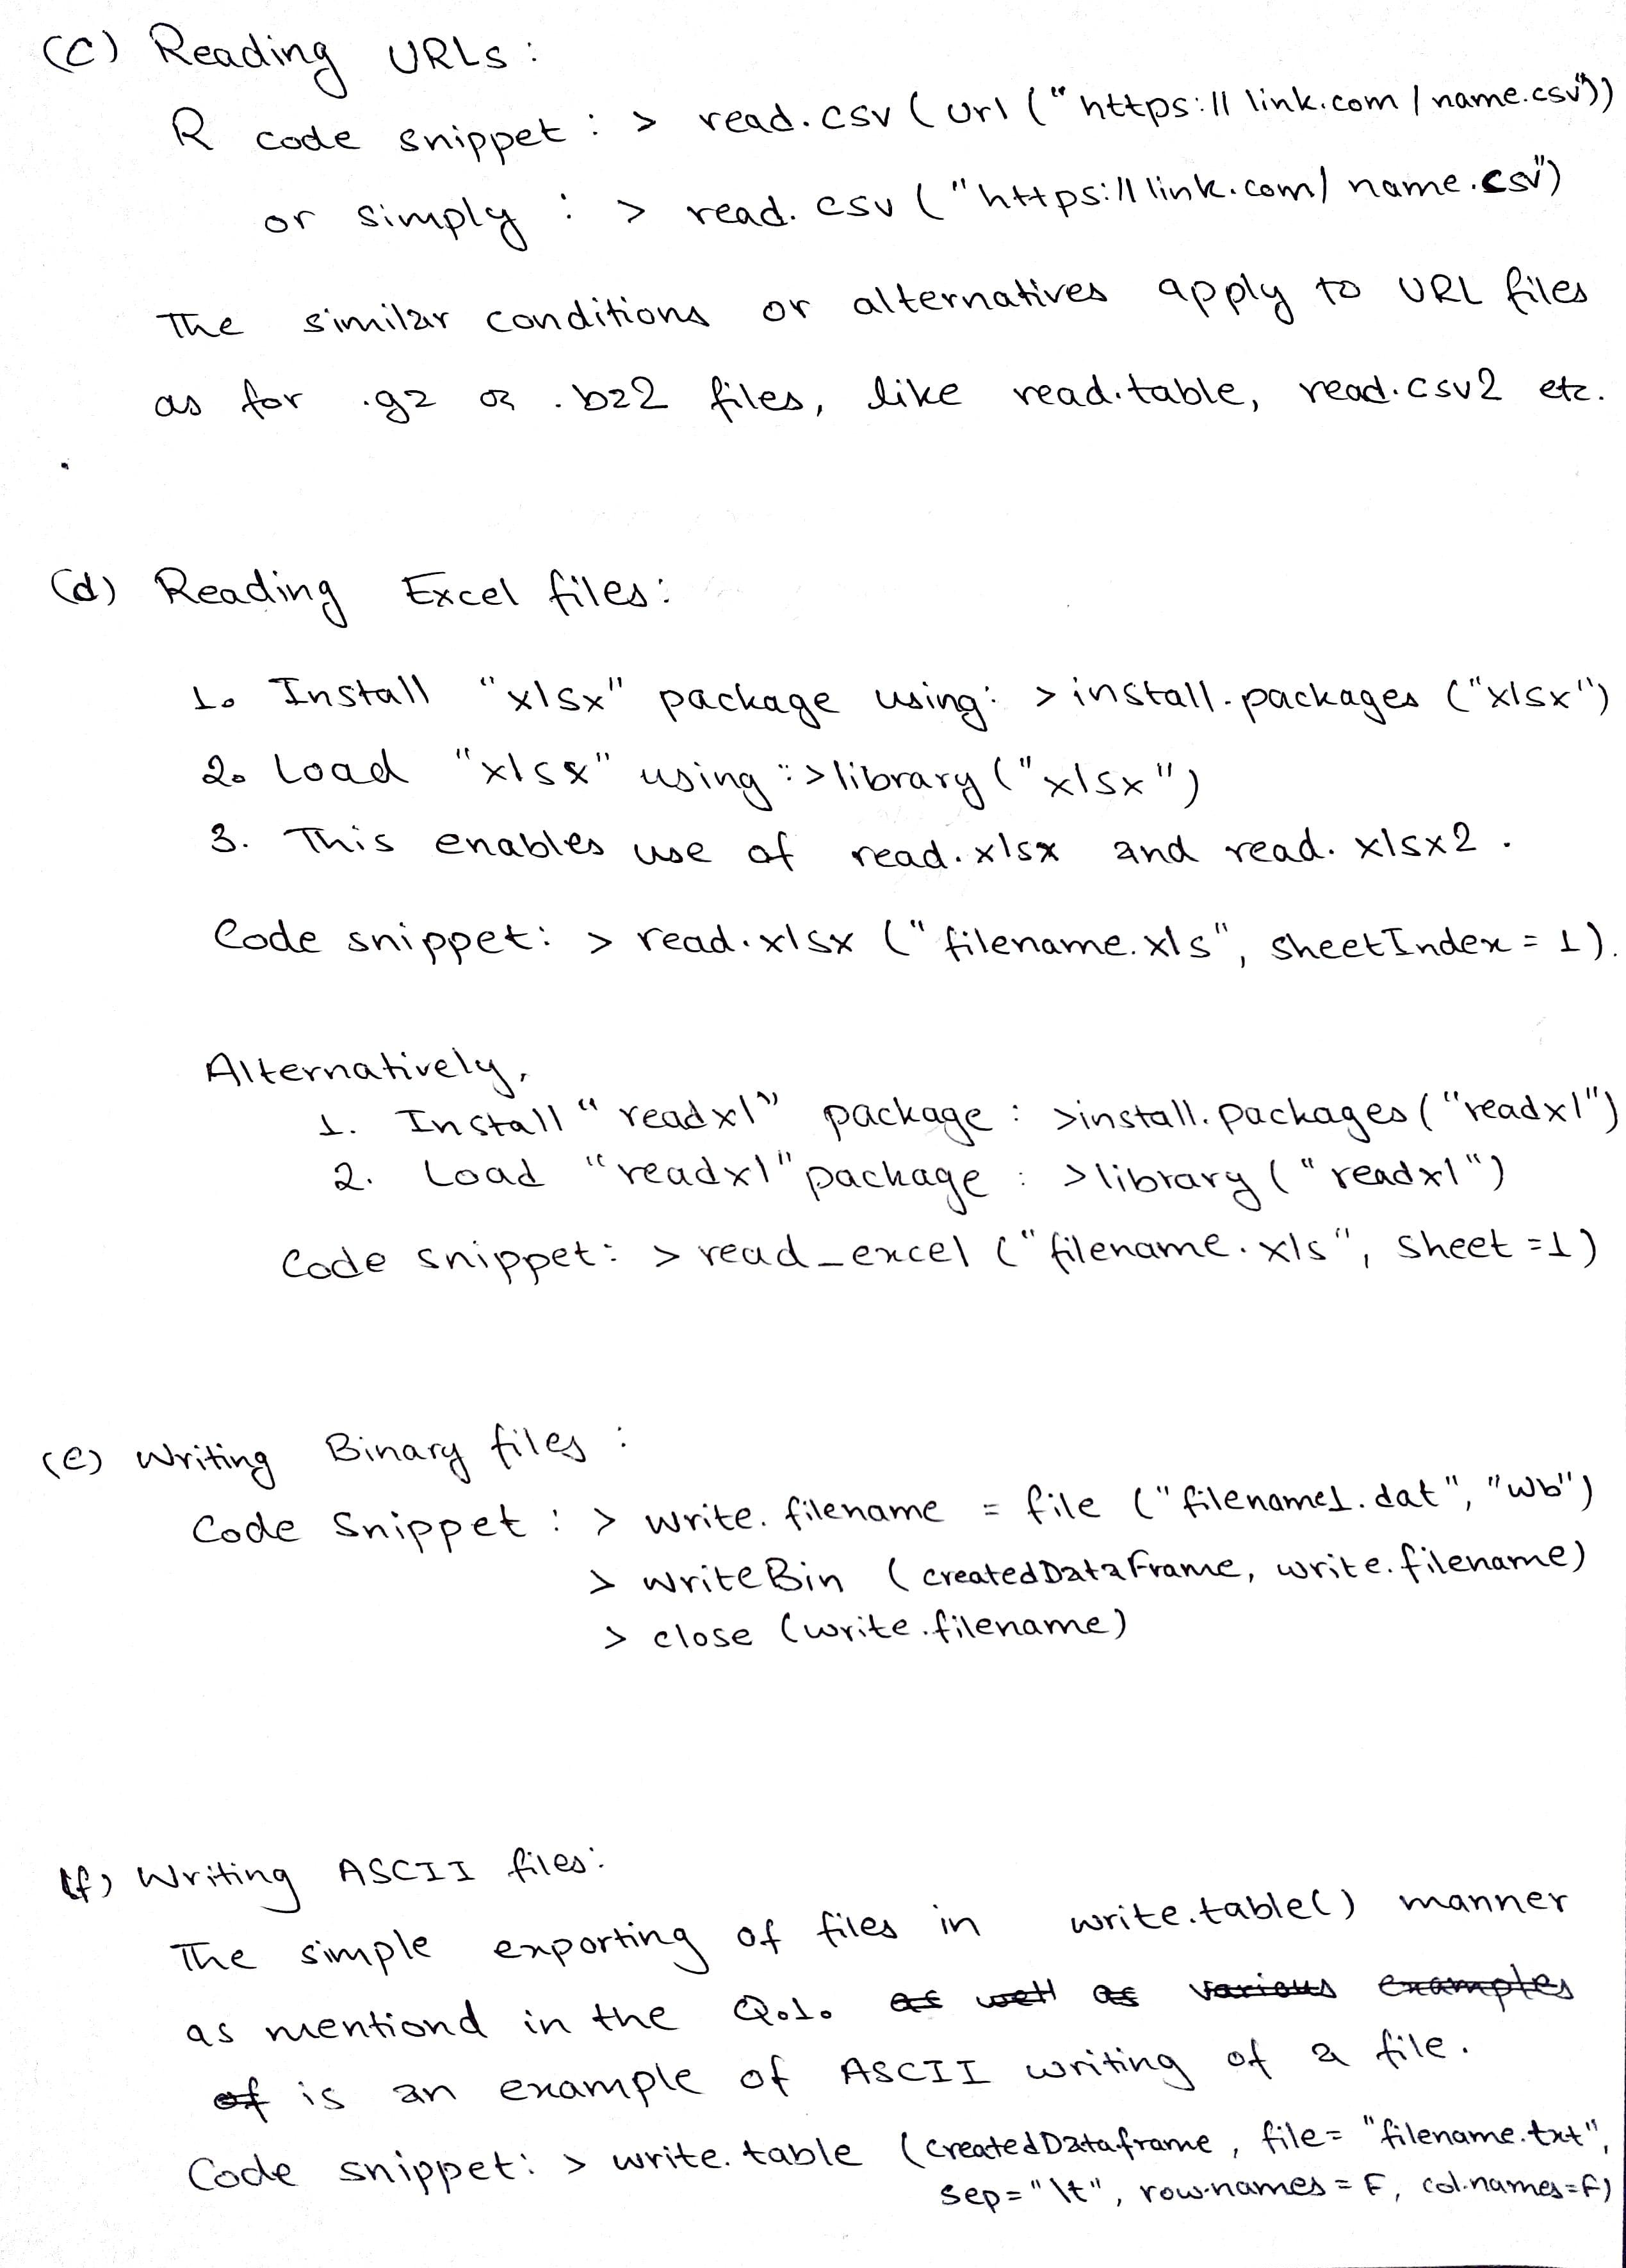

2. a. Example of Reading a random .gz file downloaded from the internet, using R:

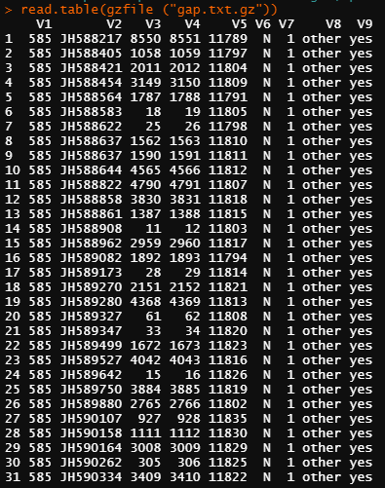

2. b. Example of reading the same .gz file converted to .bz2 file as a process of reading .bz2 file, using R:

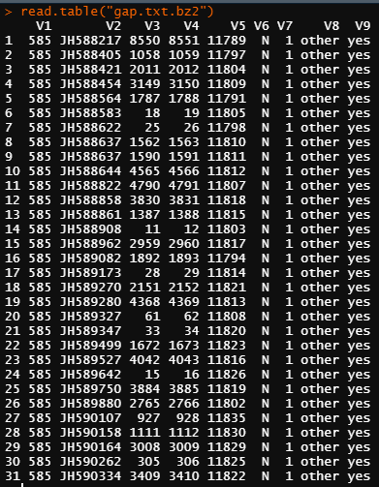

2. c. Example of reading random URL off the internet containing some csv2 data, using R:

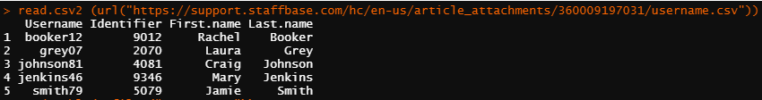

2. d. Example of reading a random MS Excel file downloaded off the internet, using R:

USING read.xlsl:

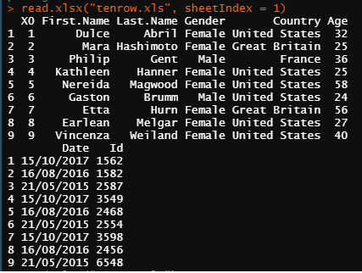

USING read_excel:

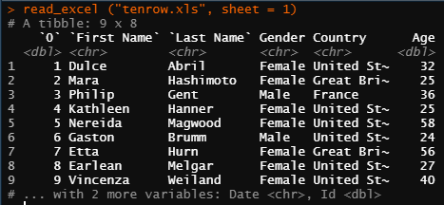

2. e. Example of writing a Binary file, using R:

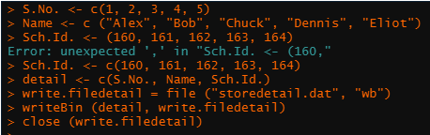

Notepad view of the binary file:

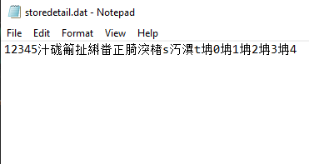  
  
Also, reading the same binary file in R:

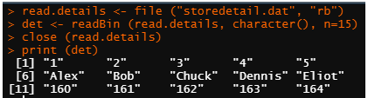

2. f. Example of writing an ASCII file, using R:

